**91897 Digital Outcome**

**Planning**

**Part A**

Describe briefly what it is you intend to build / create, why you are developing it and who it will benefit.

I intend to make a website with Charlotte discussing Mental Health Awareness. Our website will discuss a range of tips and advice on how to deal with Mental Health. There is people out there on social media who discuss their story with mental health and how they got to where they are now, we are also taking into consideration those who don't have social media and how we can still promote this issue through making a website. We have decided to create a website on mental health because we personally felt that there wasn't enough support out there for those who were finding it hard. We have made sure to create a safe and welcoming environment where people can feel safe to express their feelings as well as keeping it private and confidential so it won't be shared with anyone else.

The sections that Charlotte is working on is the Homepage for the webpage which has the overall outline of what mental health is and what the website is trying to promote which is the issue about mental health and how you can find support to help you with what your going through. The homepage has all the different topics discussed and where you can find out more information about a certain topic or just to see what else there is available.

Charlotte is also working on a section for an organisation called Heart Place with Nurse Jacqui. This a safe place where young people can go and find the support they need to make them feel more empowered and uplifted to deal with whatever they are currently finding difficult. Nurse Jacqui who owns the organisation explains her story and what happened to her when she was young and how she created a place where place for everyone to help empower them and provide some advice to help them. Charlotte has also added her own personal story from her experience and has shared what she has been through, it allows others to feel inspired by it and hopefully help them to realise that they don't need to be afraid of reaching out.

The sections I am working on are Voices of Hope and the quiz about mental health. Voices of Hope is also another organisation aimed at helping to support young teens with words of encouragement and also providing a safe place through social media where they can interact and reach out for support. I am also working on the quiz as part of our webpage, there will be a section on the webpage dedicated to the quiz where you can answer some simple questions on the topic of mental health and expressing your feelings and anything you may be going through with the support from the webpage offers you can feel confident knowing that nothing you share will be posted publicly.

**Part B**

You will be planning a bigger project for your Digital Outcome in Level 2 than you did in Level 1.   
So you will need to think carefully about planning and project management.

Answer the questions below to get you started.

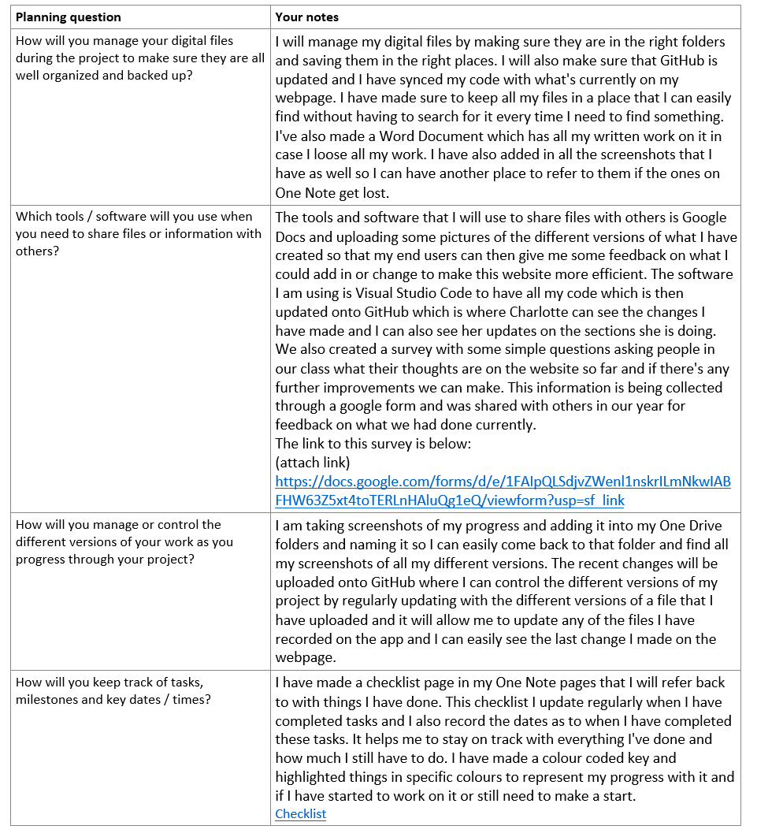

*Software I'm thinking of using:*

* GitHub
* Visual Studio code

**Part C**

Use the space below *(or other tools that you link to below)* to sketch out an action plan for your project.   
Break down the bigger goal into smaller component parts.

My Process

Design/Overview of webpage

Overview/ description on what the website provides

Sections on different topics and categories on the main menu/ dropdown options could be an option

Where you can get in touch/reach out

Quotes and positive affirmations

What is mental health

Causes, issues and how to know if you have it

Mental health stories and how these people got through it

Campaigns that have helped raise these issues

Changing the information about Jazz to be in a different place so that everything is not in the centre

Pages of website

* Section 1 Homepage - What is mental health big heading
* Section 2 Heartplace with Nurse Jacqui
* Section 3 Effects and causes on mental health
* Section 4 Voices of Hope
* Section 5 - Quiz (program)

Subpages along the top of the webpage

Planning

**Heartplace - Nurse Jacqui** <https://www.heartplace.co.nz/> (Charlotte's section)

* Brief summary of Heartplace and what it involves, what it is and how you can reach out for support
* Interview questions with Nurse Jacqui who owns Heartplace
* Strategies and tips
* Nurse Jacqui runs workshops to help empower teenagers and get the support they need for example the period workshops for those who need advice on what to do
* She has over 27 years of experience and has supported families to achieve full health, her focus is to empower those in caring roles, our careers and future careers to help them develop healthy strategies and focus on their health.

**Voices of hope (Jazz Thornton and Genevieve Mora)** <https://www.thevoicesofhope.org/>

Jazz discusses how she went through self harm as a teenager and how she kept on fighting every day, went through childhood abuse and multiple suicide attempts.

Gen also went through a eating disorder and how it affected her when she a teenager and speaks about her journey.

I am currently creating a section in our website about two women who both battled a mental illness throughout their childhood and how they overcame this struggle and deciding to share their journey with others to let them know that change is possible.

**Their mission**

Their focus is to create and implement change for mental health, whilst providing hope through the voices of those with lived experience. Voices of hope produces strategy and content with intent to influence global, communal and individual change.

Campaigns and workshops have been hosted to help those who are struggling with mental health and ways they can speak up and ask for help.

They cover a range of topics which include

* Cyber bullying
* Suicide Prevention #itsnotweaktospeak
* Body image
* Choosing to fight

Section 3 - Effects/ symptoms of Mental Health

* Confused thinking or reduced ability to concentrate
* Extreme mood changes of high and lows
* Withdrawal from friends and family
* Significant tiredness, low energy and problems sleeping

Section 4 - Voices of Hope

* What is voices of hope (brief explanation of who they are and what they do for those who are struggling)
* Information about Jazz and Gen who are the founders of voices of hope
* This section includes a blurb of information about the founders and their story on how they battled with mental health and are now advocating for change and showing people that they don't need to be afraid of having an illness.
* Their story with having a mental illness and what it was like for them (Youtube clips to be attached with both of their stories explaining their mental health journey)
* <https://www.thegirlonthebridgefilm.com/> Film that Jazz is in discussing her fighting for change around a really important subject

Overview on what Voices of Hope is

* Voices of Hope is a non-profit organisation which is aimed to break the stigma around mental illness, to decrease suicidal rates and show that hope is real and change is possible.
* They aim to create and implement change for mental health, while providing hope through the voices of those with previous experience.
* Voices of Hope provides strategies and content with intent to influence global, communal and individual change.
* It was founded in 2014 by Jazz Thornton and Genevieve Mora, both being mental health survivors they felt the need to use their past experiences along side their passion for creating and implementing change.

**Creating**

Link to google document with some more detailed information

<https://docs.google.com/document/d/1ZnGC2jbUC70X4-Ffw2jjjdSz7jGf05PABiYecMTdH7A/edit>

* Fixing the text and looking at different layouts
* Deciding on some good fonts and background options I can use
* Fixing the image because it has taken up most of the space on the page
* A link to the things that I am currently working on can be found here [Checklist :)](onenote:#Checklist%20)&section-id={D26FC6DA-B78E-4ADA-8678-B10E100727CF}&page-id={A8C3C94D-0CD6-403E-AF05-9368D0538640}&end&base-path=https://mcstudentsschool.sharepoint.com/sites/Yr12DigitalTechnology2022/SiteAssets/Yr12%20Digital%20Technology%202022%20Notebook/Ava%20Nolan/91897.one)
* Organising the webpage into sections for Jazz and Gen so there will be a section about Jazz and her journey and then one about Gen and how she dealt with mental health.

**Colour options**

Colours for background

Options

* Blue
* Green
* Beige

Screenshots of progress

For the photo above, I removed the background and also made the font bigger because it was a bit too small in the previous screenshots. I did this so that it would be easier for others to read the information that I had included, but I feel like I made it a bit too big so I may have to adjust the font a bit so its not too big. I was also thinking of changing the heading colour because I didn't really like the orange colour as it didn't match with the images I added. I also put the text in the centre so that it wasn't just on the side as I was looking at different ways the text could be displayed on the webpage.

I am also trialling different backgrounds and seeing what will work well with the webpage and not make it too hard to see what is already there.

Some background colours I'm thinking of doing are

* Cornflower blue
* Tan
* Mint green

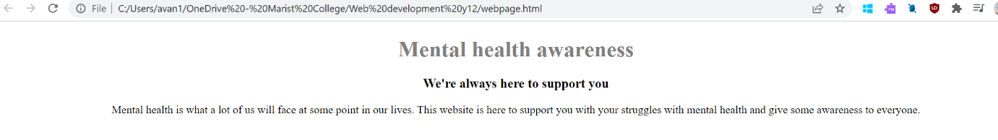**Colour options**

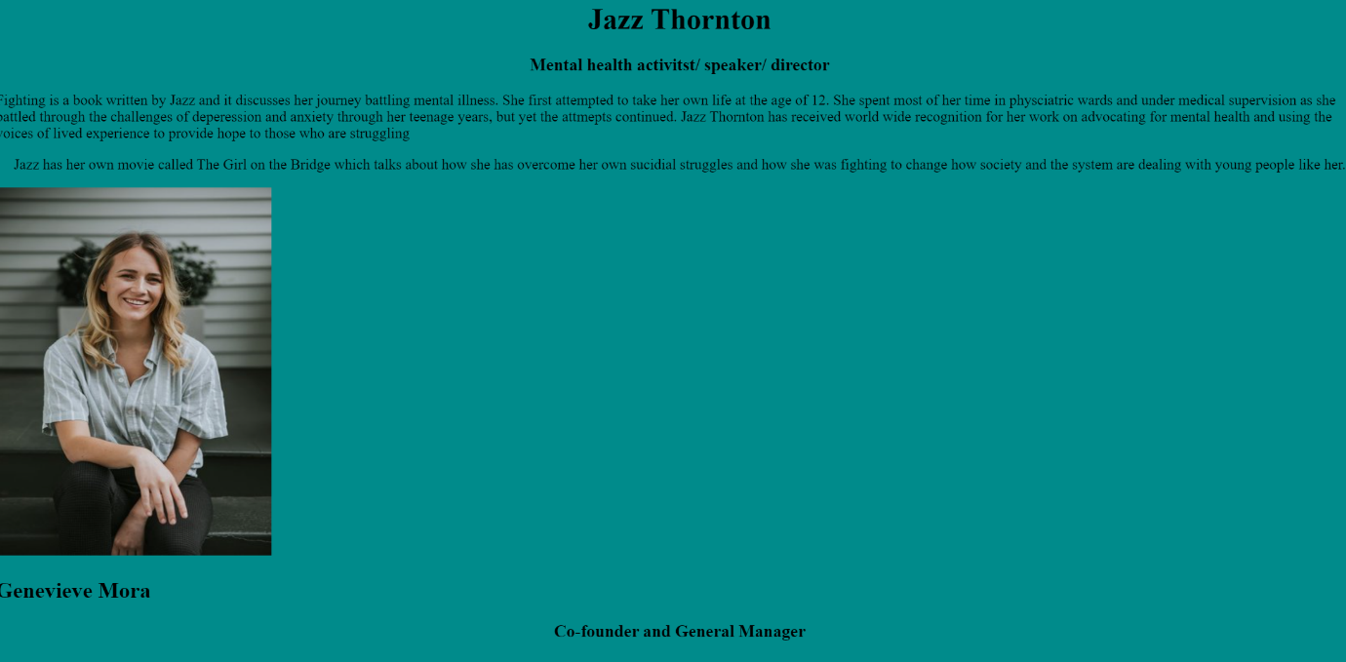

**Response to the feedback received and what I have done about it**

The process I used to gather this feedback was talking to them one on one during class and I asked them their opinion on the colour choices I came up with. I asked them what they thought of each one and why, which one they preferred and if there was anything I could improve on with the current colour choices I had. The feedback I got from asking these questions was useful and it allowed me to think of what could be done to further improve my webpage with the certain colour choices I had, I then went and looked back at my webpage with the mint green colour on it and I thought overall it fitted quite well and it wasn't too hard to read the information that was presented in front of you and it also was less in your face and gave a more chill vibe to it. I recorded all their feedback in a table and also checked in with them on the improvements I have made and their thoughts on it and if it looks better than the previous design. From the feedback I was given the end users didn't like the turquoise option and much preferred the mint green and the blue ones as they suited the overall look of the webpage better and wasn't so confusing with the fonts I had chosen to go with the background colour. It had a more chilled and relaxed vibe to it and matched the images very well and was a lot less confusing than the turquoise colour.

**Quotes on the Homepage and final design layout**

I decided to find some positive affirmations that will make you feel a little better and I attached them on the homepage of the webpage

so it will empower you to try your best and remember to think of the positive things.

I also changed the layout a bit because I wanted the quotes and the text to be laid out in a clearer way as before all the photos were in the centre and the text was above it and it just didn't look that nice.

I made the design using Canva and I was able to organise it in a way that would be easy to read as well as having the quotes displayed on the side to refer to as I thought it was a good idea to add a quote in about always trying your best and being proud of what you have achieved even if it was only a small thing.

Testing

[03. Testing](onenote:https://mcstudentsschool.sharepoint.com/sites/Yr12DigitalTechnology2022/SiteAssets/Yr12%20Digital%20Technology%202022%20Notebook/Ava%20Nolan/91897.one#03.%20Testing&section-id={D26FC6DA-B78E-4ADA-8678-B10E100727CF}&page-id={007E9C42-66C0-47B5-B1F0-3D281292F6D5}&end)  ([Web view](https://mcstudentsschool.sharepoint.com/sites/Yr12DigitalTechnology2022/_layouts/OneNote.aspx?id=%2Fsites%2FYr12DigitalTechnology2022%2FSiteAssets%2FYr12%20Digital%20Technology%202022%20Notebook&wd=target%28Ava%20Nolan%2F91897.one%7CD26FC6DA-B78E-4ADA-8678-B10E100727CF%2F03.%20Testing%7C007E9C42-66C0-47B5-B1F0-3D281292F6D5%2F%29))